Identifying Acids and Bases

Liquids all around us have either acidic or basic properties. For example, acids taste sour while bases taste bitter and feel slippery. However, both strong acids and strong bases can be very dangerous and burn your skin, so it is important to be very careful when using such chemicals. In order to measure how acidic or basic a liquid is, a person must use the pH scale as illustrated below:
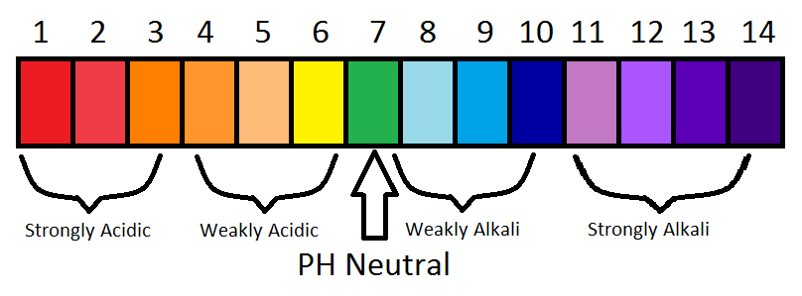
This Photo by Unknown Author is licensed under CC BY-SA

The strength of the pH scale is determined by the concentration of hydrogen ions (H+) where a high concentration of H+ ions indicates a low pH and a high concentration of H+ ions indicates a high pH. The pH scale ranges from 1 to 14 where 1 to 6 is classified as acidic, 7 is neutral (neither acid or base) and 8 to 14 is classified as basic.

In this lab you will use juice from red cabbage as a pH indicator to test common household liquids and determine their pH levels. You will mix cabbage juice with different household liquids and see a color change produced by a pigment called flavin (an anthocyanin) in red cabbage. Through this color change, you will be able to successfully identify the approximate pH of common household liquids using the table below:

Color | Pink | Dark Red | Violet | Blue | Blue-Green | Green-Yellow
Approx. pH | 1-2 | 3-4 | 5-7 | 8 | 9-10 | 11-12
Acid/Base | Acid | Acid | Acid/Neutral | Base | Base | Base

Materials
Graduated Cylinders
Safety Goggles
Pipettes
Test tubes
Test tube racks
Beakers
Watch glasses

Liquids and solids to test
Vinegar
Baking Soda
Shampoo
Conditioner
Hand Sanitizer
Coca Cola
Distilled Water
Warhead candies

Pre-Laboratory Predictions:

Look at each of the items being tested. Predict whether each of the substances is acidic, neutral, or basic. Circle one. (Think about the properties of acids and bases.)

Vinegar Acidic Neutral Basic
Baking Soda Acidic Neutral Basic
Shampoo Acidic Neutral Basic
Conditioner Acidic Neutral Basic
Hand Sanitizer Acidic Neutral Basic
Coca Cola Acidic Neutral Basic
Warheads Acidic Neutral Basic

Safety

Remember the safety lessons. This lab will require proper protective gear, in this case goggles. There will be no messing around tolerated. If you are caught messing around in the lab you will be made to sit and wait till the lab is done, not participating and receive a zero in the lab.

Procedure

Part 1:
On the side bench you will find test tubes and test-tube racks.
- In your group, you will grab a test tube rack and 7 test tubes.
- For each of the test tubes you will have to label it with tape which substance you are testing.
- In each tube you will place 20 mL of the substance to be tested.
- To each test tube you will then pour 10 mL of cabbage juice. Do this one at a time and record the color change below.
- Using the color change, and the table on page 1, predict the pH of each substance.

Test Tube | Acid or Base | Color Change | pH | Actual pH
1 | Vinegar
2 | Baking Soda
3 | Shampoo
4 | Conditioner
5 | Hand Sanitizer
6 | Coca Cola
7 | Distilled Water
Now look up the actual pH of each of the substances and see how accurate the cabbage juice indicator was!
- Categorize the results of your substances below:
Strong Acids | Weak Acids | Neutral | Weak Bases | Strong Bases

- Now, try adding small amounts of baking soda to the acidic substance tubes, record what happened to the color of each test tube below and answer the questions. (Does color intensity of the liquid change? If so, how and why do you think this is?)

Concept Questions:

- Does the addition of baking soda (in water) alter the pH of weak acids and bases? How does it change the pH?

- How does a difference in 1 pH unit change in terms of H+ concentration? Example: How does a pH of 3 differ from a pH of 4? Which one is stronger or weaker? Why?

- Look up the ingredients for each substance tested. Which ingredients contribute to each of the substances’ pH levels?

Real Life Applications:

- Why is Alka-Seltzer used to treat stomach aches? (Note: excess stomach acids cause stomach aches) (Hint: Is Alka-Seltzer an acid or a base? Look it up.)

