H | 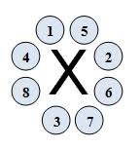 |  |  |  |  |  | He
Li | Be | B | C | N | O | F | Ne
Na | Mg | Al | Si | P | S | Cl | Ar
K | Ca |  | Instructions:  Using what you have learned today about the Lewis dot model, draw a Lewis dot diagram for each of the elements on this table. Remember to write the symbol of the element in the middle, with the electrons from the valence shell placed around them in the order shown above.
LEWIS DOT DIAGRAMS PRACTICE

