**M&M’s Balancing Equations Lab**

**Background**: The law of conservation of mass states – _______________________________________

A chemical formula is – ____________________________________________________

A coefficient is – _________________________________________________________

A subscript is – ___________________________________________________________

**Directions**:

 1. Use the M&M’s to model atoms.

2. Set up the reactants using the correct number of M&M’s. Move the same M&M’s to the product side. As they become more difficult you may need to set

up the products first and work backwards.

3. Set up the molecules and fill in the coefficients

4. Draw and color the equations that represent the reactions.

**Data Table**:

|  |  |  |  |  |  |  |
| --- | --- | --- | --- | --- | --- | --- |
| **Atom** | **O** | **H** | **Na** | **Cl** | **K** | **Ca** |
| **Color:** | Blue | Brown | Orange | Yellow | Red | Green |
| **Number** | 12 | 8 | 4 | 4 | 4 | 2 |

Understanding Balanced Chemical Equations:

When chemicals react, atoms are conserved. This means that there must be the same number of each atom on each side of the arrow.

Look at the reaction H2 + O2 🡪 H2O

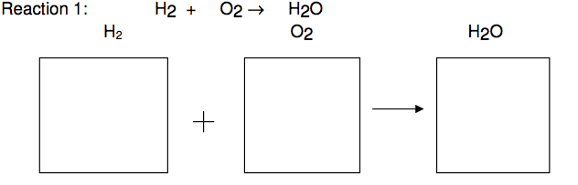

How many H candies are on the left side __________ , right side ___________

You can eat the M&M’s – **but not until after the lab!**

How many O candies are on the left side __________, right side ____________

Is the equation currently balanced? Yes/ No



Write the correctly balanced equation:

|  |  |  |  |  |  |  |
| --- | --- | --- | --- | --- | --- | --- |
| **Atom** | **O** | **H** | **Na** | **Cl** | **K** | **Ca** |
| **Color:** | Green | Yellow | Orange | Blue | Red | Brown |
| **Number** | 12 | 8 | 4 | 4 | 4 | 2 |

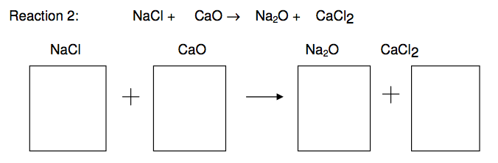

Reaction 2: Write the balanced chemical equation:

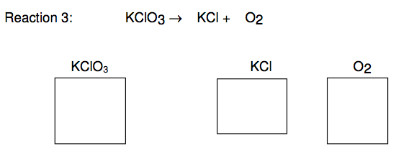

Reaction 3: Write the balanced chemical equation:

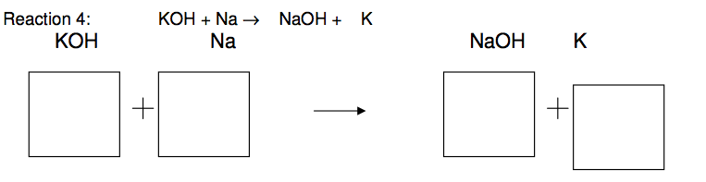

Reaction 4: Write the balanced chemical equation:

|  |  |  |  |  |  |
| --- | --- | --- | --- | --- | --- |
| **Atom** | **O** | **H** | **C** | **S** | **Br** |
| **Color:** | Green | Yellow | Blue | Red | Brown |
| **Number** | 12 | 8 | 4 | 4 | 2 |

**Balance the equation then write the final formula.**

**Draw out the M & M diagram of the balanced equation.**

1. ___ H2O + ___ SO3 🡪 ___ H2SO4

2. ___ H2 + ___ Br2 🡪 ___ HBr

3. ___ C + ___H2 🡪 ___CH4

4. ___ C + ___ O2 🡪 ___ CO

Don’t forget! You can change the coefficient, but you can not change the subscript!

5. ___ H2O2 🡪 ___ H2O + ___ O2



Analysis Questions:

1. What do the M & M’s stand for in this lab?

2. What is the coefficient and what does it apply to?

3. What are the steps to balancing a chemical equation?

4. How does the Law of Conservation of Matter apply to chemical reactions?

Homework

Balance these equations:

1. ___ Zn + ___ HCl 🡪 ___ ZnCl + ___ H2

2. ___ KNO3 🡪 ___ KNO2 + ___ O2

3. ___ HCl + ___ CaCO3 🡪 ___ CO2 + ___ H2O + ___ CaCl2