Brandt
Biology 30
Athlete Vs. Animal
Working in pairs or small groups, please complete each of the events listed and record your data in the table provided. Once complete- please return to the class to compare your data to that of other members of kingdom Animalia.
Event | Group Member A | Group Member B | Group Member C
100m Sprint

Standing Jump Distance

Reaction Time
(using 30cm ruler)

Average sleep per day
(estimate)

Breath hold

Weight Lift
(be careful!)

Color Vision Test
(App) see website

Your Choice A

Your Choice B

Once complete- please return to the class to compare your results.
Athlete Vs. Animal Results
Running Speed:
Animal running speeds
Lion – 80kph
Horse – 65kph
Grizzly bear – 48kph
Chihuahua – 32kph
Hippopotamus – 30kph
Goat – 24kph
Squirrel – 20 kph
Basset hound – 12kph
Hamster – 11kph
Tortoise – 0.35 kph

Physical Strength (% of body weight)
Human times and Speeds to Run 100 Metres
10 secs – 36.00kph
12 secs – 30kph
14 – 25.7 kph
16 – 22.5 kph
18 – 20 kph
20 – 18 kph
22 – 16.3 kph
24 – 15 kph
26 – 13.8 kph
28 – 12.8 kph
30 – 12 kph
32 – 11.25 kph
1 minute – 6 kph
Breath Hold (calculate a class average)

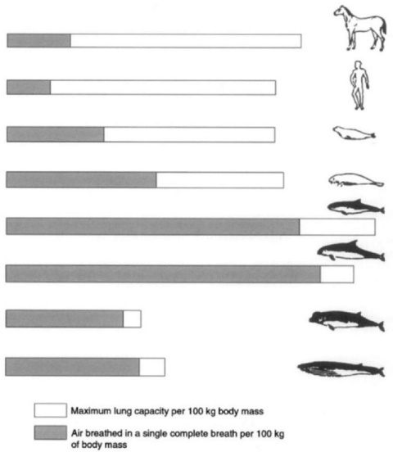
Lbs lifted x 100% =
lbs weight
Family Dog- 40% of body weight
Grizzly Bear- 80% of body weight
Anaconda- 100% of body weight
Muskox- 150% of body weight
Tiger- 200% of body weight
Bald Eagle- 400% of body weight
Gorilla- 1000% of body weight

Sleep per day
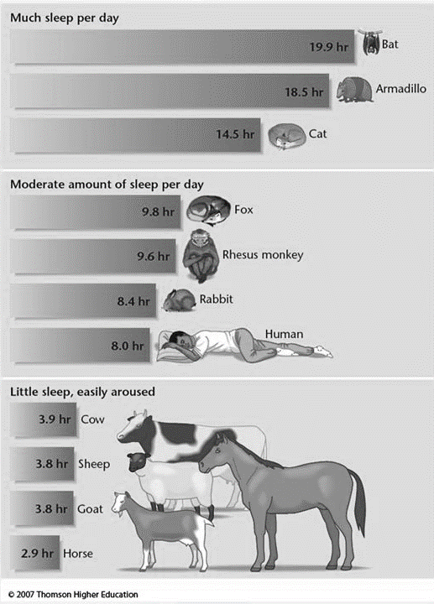

Standing Jump
Human- 3.74m (11’4”= 136”)
